Unit 2 – Forces in 2D (Student Sheet)

Engineering Statics in Physics Project
Carnegie Mellon University and Pittsburgh Area Schools

Paul S. Steif, Carnegie Mellon University
Janet R. Waldeck, Pittsburgh Allderdice High School

© July 13, 2013 Paul S. Steif and Janet R. Waldeck. All rights reserved.

2.1 Forces can change the direction of motion

Carefully roll a bowling ball at a constant speed down the hallway. Apply a tap from a mallet to get the ball to make a turn while in motion:

On the diagram above, draw an arrow to indicate the force (size and direction) needed to make the bowling ball turn as shown

On the xy-axis shown below, draw an arrow to represent the force you used to change the direction of the moving bowling ball. Place the tail of the arrow at the origin and label “direction” in terms of the angle relative to the positive x-axis.

y

x

  - Forces are vectors

(i) using opposing spring scales to maintain equilibrium

Hold a ring in position with four spring scales, with each scale flat on the table. Align the scales with the horizontal and vertical lines drawn on the next page, with the ring centered with respect to the origin. Try to pull with different forces on the scales A and B. Record values in the table below for several different cases. Compare the forces in scales A and C and in B and D. What is the conclusion?

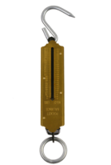
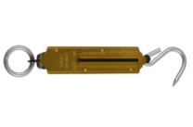
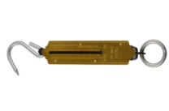
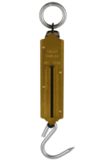
D
A
B
C
D

Case | Scale A (N) | Scale B (N) | Scale C (N) | Scale D (N)
1
2
3
4
5

Conclusion:

(ii) using three spring scales to maintain equilibrium

Replace spring scales C and D with a single spring scale E. The person with scale E should adjust the force and the angle, so the ring does not move.
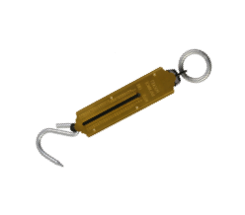
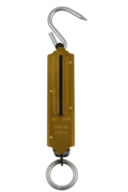
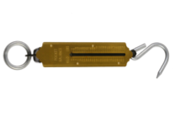
A
B
E

Try these combinations of forces in scales A and B: A = 5 N, B = 5 N; A = 10 N, B = 5 N; A = 15 N, B = 5 N.. Hold the ring over the axis origin on the next page, scale A along the (-)-horizontal axis and scale B along the (-)-vertical axis. Draw a labeled line parallel to E for each of the three cases. Use that line to determine the angle of E relative to the (+)-horizontal line. Record the force of scale E (Scale E Force) and the angle of scale E (Scale E angle) relative to the (+)-horizontal axis in the table below. The columns “Hypotenuse” and “Triangle angle” will be filled in later.

Triangle | Hypotenuse | Scale E Force (N) | Triangle angle | Scale E angle
5 by 5
10 by 5
15 by 5

Draw three right triangles below, with the legs as listed:
Vert.
Leg

Horiz.
Leg

Drawing of Triangle
Horiz. Leg = 5 cm
Vert. Leg = 5 cm

Drawing of Triangle
Horiz. Leg = 10 cm
Vert. Leg = 5 cm

Drawing of Triangle
Horiz. Leg = 15 cm
Vert. Leg = 5 cm

For each triangle measure the length of the hypotenuse and the angle the hypotenuse makes with respect to the horizontal axis. Enter these values into the columns “Hypotenuse” and “Triangle angle” in the table above. In each of three cases, compare what you found for the hypotenuse with what you found for the force in scale E and its angle.

Scale E does what scales C and D together did. So how do forces combine?

2.3 Balancing forces in two dimensions

In rock climbing, cords connected to anchors in the rock hold you up. The cords will be oriented at different angles, which affect the forces. Clamps on oppositely facing chemistry support stands can serve as the anchors to hold the spring scales. Place books on the stand bases if they tend to slip or tip. Use S-hooks to connect the scales to a central ring and to hang the block from the ring.

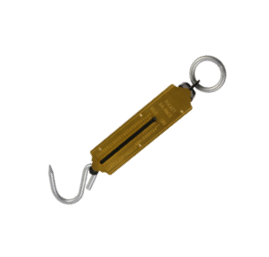
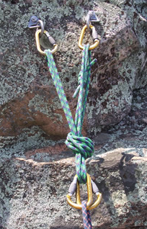
Block
ring
θ
θ

Record the combined weight of the block, S-hooks, and ring ___________

(i) spring scales oriented symmetrically

Place the support stand clamps at the same height, and attach the scales to the clamps and the ring, so that the scales make the same angle with respect to the horizontal. Record the scale readings and the angle used for three different configurations.

Left scale tension | Right scale tension | Angle θ with horizontal

How do the scale readings change, as the stands are placed farther apart?

On the xy-axis below, draw a vector starting at the origin to represent the scale tension for each trial. The length of each vector should be proportional to the value of tension recorded. And the vector should be positioned to represent accurately the direction of the scale force (i.e. the correct angle). Draw a vector starting at the origin representing the weight force.

(ii) spring scales oriented unsymmetrically

Attach the clamps to the stand at different heights so that each scale makes its own angle with respect to the horizontal axis (θ_{L} and θ_{R}). Make sure that they are positioned so each scale stretches, but not to its maximum reading.

Block
ring
θ_{R}
θ_{L}

Weight
T_{R}
T_{L}

Repeat this multiple times, recording the angles and scale readings in the table below.

Left tension T_{L} | Left angle θ_{L} | Right tension T_{R} | Right angle Θ_{R}

Using the measurements, you will calculate the net force in x direction and the y direction on the ring. We can use trigonometry to solve for the horizontal component and vertical component of a force vector. For example,

D = F cos θ

C = F sin θ
F
C
θ

D

Use these trig functions to resolve each scale force vector (recorded above) into horizontal and vertical components. The scale tension corresponds to the magnitude F, which is different for left and right scales.

For example:
T_{Rx} (right scale horizontal) = T_{R} cos θ_{R} and T_{Ry} (right scale vertical) = T_{R} sin θ_{R}

Enter the horizontal and vertical components due to each scale into the table.

Next, determine the total horizontal force and the total vertical force. Let x be positive if to right, negative if to left. Let y be positive if up, negative if down.

Horizontal Components |  |  | Vertical Components
T_{Rx} | T_{Lx} | T_{Rv} - T_{Lx} | T_{Rv} | T_{Ly} | W | T_{Rv} +T_{Lv} - W

What trend(s) do you notice with the total horizontal force?

What trend(s) do you notice with the total vertical force?

  - Forces experienced by a body on a ramp

(i) a spring scale opposes the component of gravity pulling a truck down the ramp

Weigh a wooden toy truck. Weight of truck = __________N_

Place the truck on a level ramp and add a weight (about 1 kg) to the truck. Then, raise one end of the ramp and use a spring scale, hooked onto the truck and held parallel to the ramp, to keep the truck in place. With the ramp held at three different angles (approximately 30°, 45°, 60°) record the reading on the spring scale.

Angle | Measured Spring Force Parallel to Ramp

In order for the truck to remain in place, the force pulling the truck down the inclined plane must be balanced by the upward pull of the spring scale. Here are all the forces on the truck:
F_{scale}
θ
W
F_{N}
F_{scale}

θ

The force F_{N} does not affect balance of forces along the inclined plane. To better understand how W and F_{scale} balance, we will use trigonometry to find the pull due to gravity along the inclined plane.
W
θ
F_{scale}
W
F_{scale}
θ

F_{N}

Notice that when the ramp is on an angle θ, it appears to form a right-triangle with one side along the table’s surface. By turning your head by θ, you can imagine the new y-axis to be oriented perpendicular to the ramp’s surface and the force due to the spring scale to then point along the (+)-horizontal axis. From consideration of the angle θ, one can calculate the component of W along the (-)-horizontal axis: │F_{x}│= W ∙ sinθ. To see if this component does indeed fulfill our expectation, calculate it for each of the three angles recorded above and compare to the scale readings.

Angle | W (= Truck + Added Weight) | W ∙ sinθ | Measured Spring Force Parallel to Ramp

(ii) force due to friction between a block and the incline surface will serve to counter the component of gravity pulling the block down the ramp

Weigh a large block. The magnitude of the block’s weight is equal to the normal force (N) on the block when it rests on a horizontal surface. Obtain three different fabric samples: gray, flannel and brown.

Weight of large block = ___________

For each fabric, in turn, lay the fabric on a horizontal surface and place the block on the fabric. Pull horizontally with a spring scale, recording the minimum force needed to cause the block to slip. From this value, calculate the coefficient of static friction (μ_{s,max}) for the block/fabric system.

Fabric | Force to Initiate (F_{s}) | Normal Force = N | μ_{s,max} = F_{s} /N
Gray – Trial 1
Gray – Trial 2
Gray – Trial 3
Flannel – Trial 1
Flannel – Trial 2
Flannel – Trial 3
Brown – Trial 1
Brown – Trial 2
Brown – Trial 3

Fabric | Gray | Flannel | Brown
Average μ_{s,max}

Next, place each of the cloths, in turn, on the board and place the large block on the cloth. Tilt the board until the block starts to slip and record the angle of the board where slipping first starts to occur.

Surface | Angle where slipping begins to occur
Gray
Flannel
Brown

Here are all the forces on the block:
F_{fric}
θ
W
F_{N}
F_{fric}
θ
W

F_{N}

Again, tilt your head by θ. The force of gravity has components along the inclined plane and perpendicular to it.
W
θ
W∙sinθ
W∙cosθ

For the block to remain stationary, F_{fric} = W∙sinθ, and the normal force F_{N} is balanced by the component of W perpendicular to the ramp’s surface, F_{N} = W∙cosθ.

When the inclined plane is gradually tilted, the block slips at an angle θ_{s}. This was measured and depends on the fabric. The friction force has reached the maximum value F_{fric,max} = μ_{s} ∙ F_{N} . So μ_{s} = F_{fric,max} / F_{N} = W∙sinθ_{s} / W∙cosθ_{s} = sinθ_{s} / cosθ_{s}. From the measured angle θ_{s}, calculate the coefficient of static friction. Compare with the measurements of μ_{s} from pulling the block along the fabric.

Fabric | θ_{s} (angle when slipping begins to occur | μ_{s} = sinθ_{s} / cosθ_{s} | μ_{s} (pulling block on fabric)

